

**Final Term Assignment**

**Course Name** : [Web](https://portal.aiub.edu/Student/Section?q=nDsTpWMIgZm0mzYYaYBCOg%3D%3D) Technologies

**Course Teacher** : Rashidul Hasan Nabil

**Course Code** : CSC3215

**Name** : Jahan, Nusrat

**ID** : 19-40059-1

# **Assignment Title: Implementing 4 Features using AJAX**

**Feature 1: Live Search**

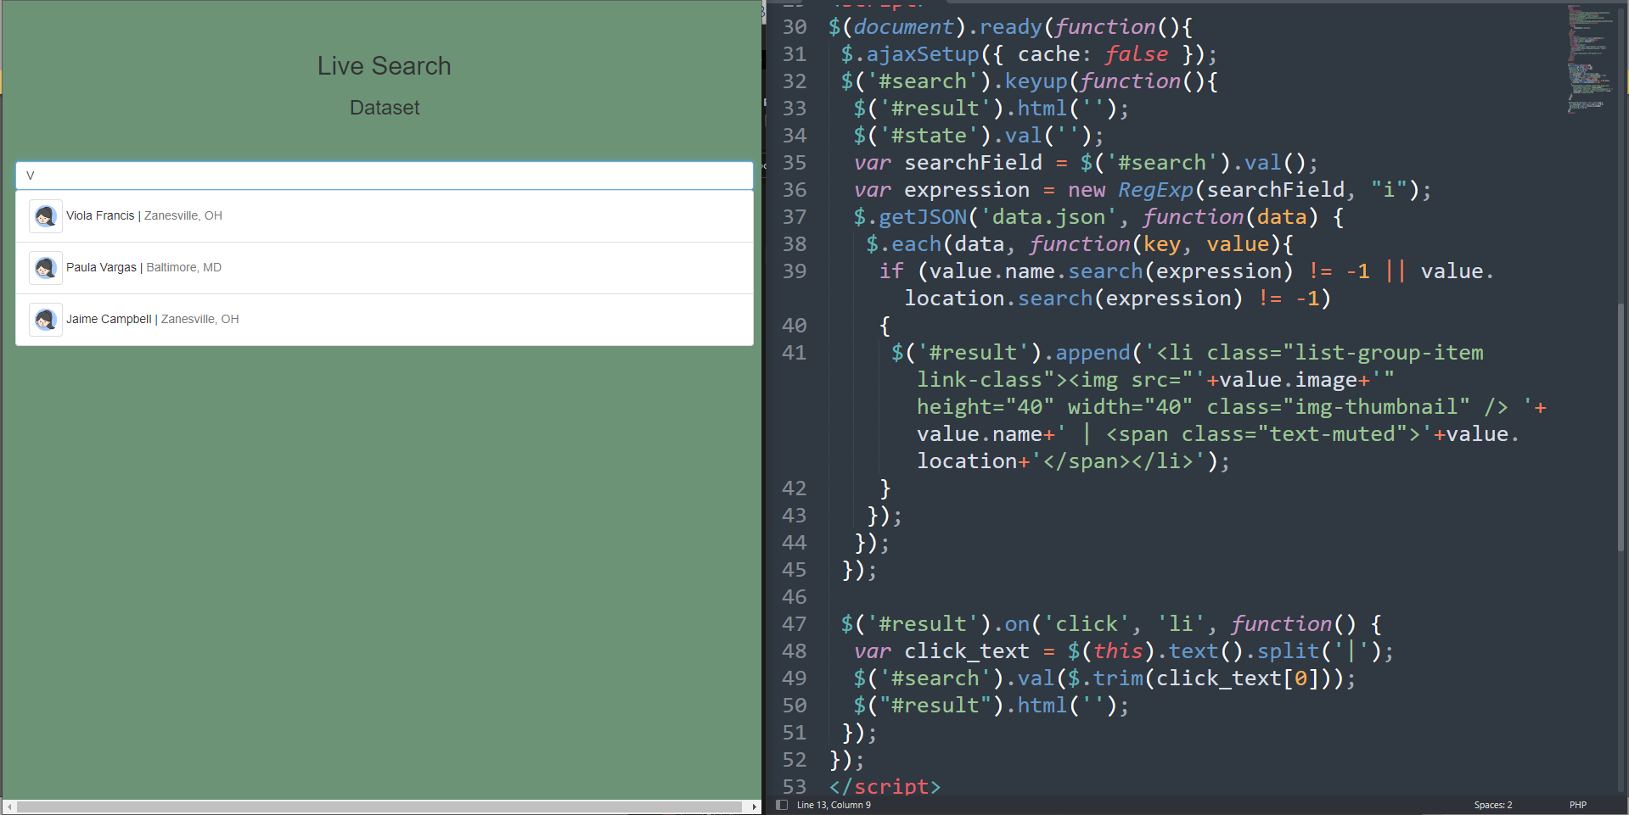

**Feature 2: Live Voting**

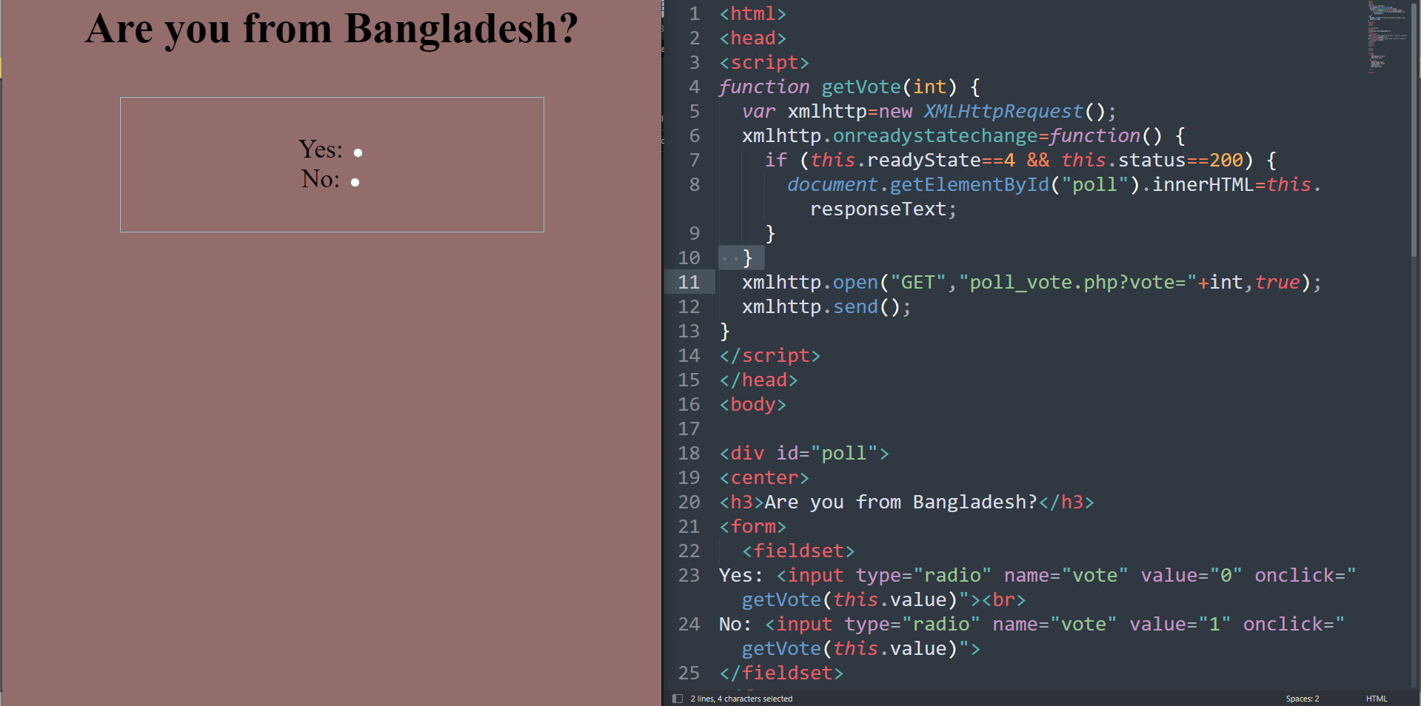

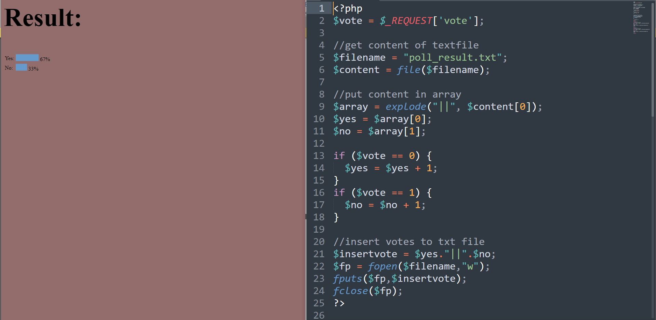

**Feature 3: Live form data**

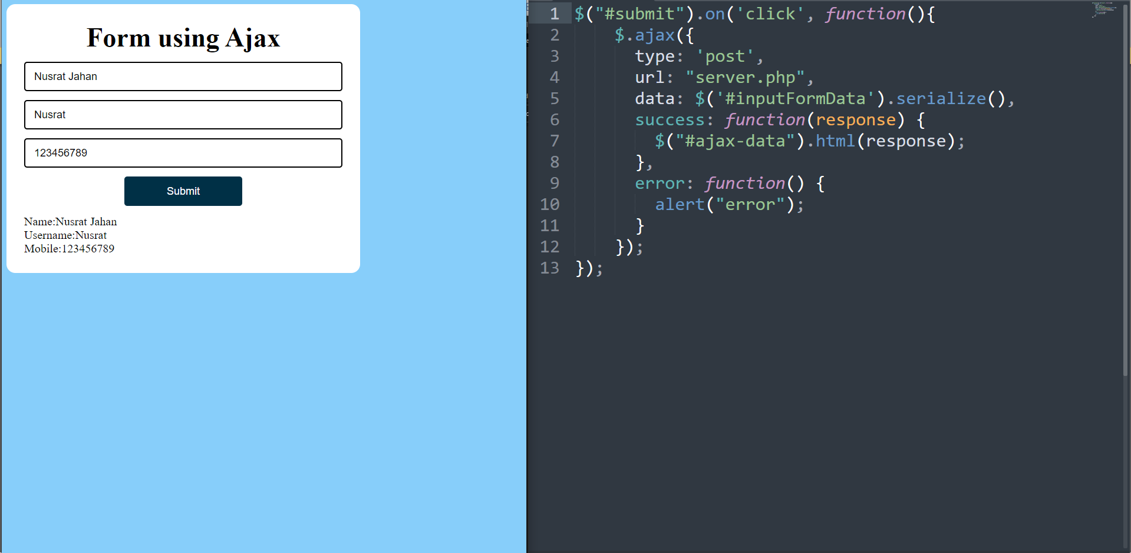

**Feature 4: Live Chat option**

